[Thực hành] Thực hành xây dựng JWT

Mục tiêu
Xây dưng và sử dụng được JWT

Mô tả
Trong phần này, chúng ta sẽ phát triển một ứng dụng sử dụng Spring Security và Restful API.
Ứng dụng sẽ cho phép truy cập vào các API cần có quyền truy cập.

Hướng dẫn
Bước 1: Tạo project Gradle mang tên spring-jwt
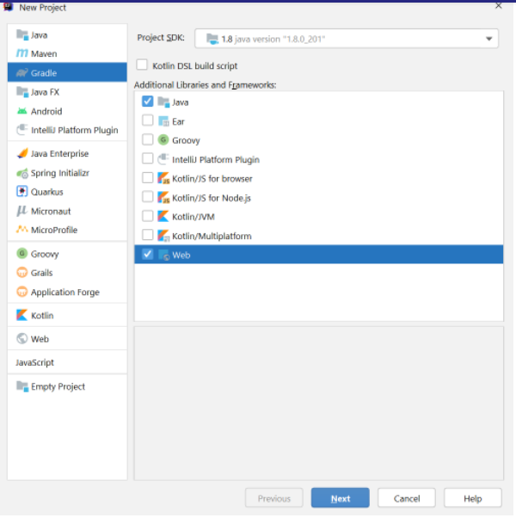
Bước 2: Thêm các dependencie cho project
dependencies {
providedCompile group: 'javax.servlet', name: 'javax.servlet-api', version: '4.0.1'
compile group: 'org.springframework', name: 'spring-core', version: '5.3.2'
compile group: 'org.springframework', name: 'spring-context', version: '5.3.2'
compile group: 'org.springframework', name: 'spring-beans', version: '5.3.2'
compile group: 'org.springframework', name: 'spring-web', version: '5.3.2'
compile group: 'org.springframework', name: 'spring-webmvc', version: '5.3.2'
compile group: 'org.springframework.security', name: 'spring-security-web', version: '5.4.2'
compile group: 'org.springframework.security', name: 'spring-security-config', version: '5.4.2'
compile group: 'org.springframework.security', name: 'spring-security-taglibs', version: '5.4.2'
compile group: 'org.hibernate', name: 'hibernate-core', version: '5.3.0.Final'
compile group: 'org.hibernate', name: 'hibernate-entitymanager', version: '5.3.0.Final'
compile group: 'org.springframework', name: 'spring-orm', version: '5.3.2'
compile group: 'mysql', name: 'mysql-connector-java', version: '8.0.22'
compile group: 'org.springframework.data', name: 'spring-data-jpa', version: '2.4.2'
compile group: 'org.springframework', name: 'spring-tx', version: '5.3.2'
compile group: 'com.fasterxml.jackson.core', name: 'jackson-databind', version: '2.12.1'
compile group: 'io.jsonwebtoken', name: 'jjwt', version: '0.9.1'
}
Tạo cấu trúc thư mục cho project
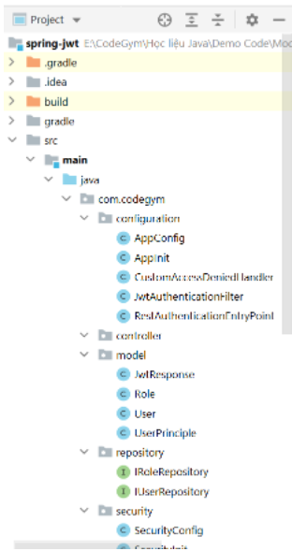
Bước 3: Cấu hình cho project trong thư mục configuration
AppInit
package com.codegym.configuration;
import org.springframework.web.servlet.support.AbstractAnnotationConfigDispatcherServletInitializer;
public class AppInit extends AbstractAnnotationConfigDispatcherServletInitializer {
@Override
protected Class<?>[] getRootConfigClasses() {
return new Class[]{AppConfig.class};
}
@Override
protected Class<?>[] getServletConfigClasses() {
return new Class[]{SecurityConfig.class};
}
@Override
protected String[] getServletMappings() {
return new String[]{"/"};
}
}
AppConfig
package com.codegym.configuration;
import org.springframework.beans.BeansException;
import org.springframework.beans.factory.annotation.Qualifier;
import org.springframework.context.ApplicationContext;
import org.springframework.context.ApplicationContextAware;
import org.springframework.context.annotation.Bean;
import org.springframework.context.annotation.ComponentScan;
import org.springframework.context.annotation.Configuration;
import org.springframework.data.jpa.repository.config.EnableJpaRepositories;
import org.springframework.data.web.config.EnableSpringDataWebSupport;
import org.springframework.jdbc.datasource.DriverManagerDataSource;
import org.springframework.orm.jpa.JpaTransactionManager;
import org.springframework.orm.jpa.JpaVendorAdapter;
import org.springframework.orm.jpa.LocalContainerEntityManagerFactoryBean;
import org.springframework.orm.jpa.vendor.HibernateJpaVendorAdapter;
import org.springframework.transaction.PlatformTransactionManager;
import org.springframework.transaction.annotation.EnableTransactionManagement;
import org.springframework.web.servlet.config.annotation.EnableWebMvc;
import org.springframework.web.servlet.config.annotation.WebMvcConfigurer;
import javax.persistence.EntityManager;
import javax.persistence.EntityManagerFactory;
import javax.sql.DataSource;
import java.util.Properties;
@Configuration
@EnableWebMvc
@EnableTransactionManagement
@EnableJpaRepositories("com.codegym.repository")
@ComponentScan("com.codegym")
@EnableSpringDataWebSupport
public class AppConfig implements WebMvcConfigurer, ApplicationContextAware {
private ApplicationContext applicationContext;
@Override
public void setApplicationContext(ApplicationContext applicationContext) throws BeansException {
this.applicationContext = applicationContext;
}
//Cấu hình JPA
@Bean
@Qualifier(value = "entityManager")
public EntityManager entityManager(EntityManagerFactory entityManagerFactory) {
return entityManagerFactory.createEntityManager();
}
@Bean
public LocalContainerEntityManagerFactoryBean entityManagerFactory() {
LocalContainerEntityManagerFactoryBean em = new LocalContainerEntityManagerFactoryBean();
em.setDataSource(dataSource());
em.setPackagesToScan("com.codegym.model");
JpaVendorAdapter vendorAdapter = new HibernateJpaVendorAdapter();
em.setJpaVendorAdapter(vendorAdapter);
em.setJpaProperties(additionalProperties());
return em;
}
@Bean
public DataSource dataSource() {
DriverManagerDataSource dataSource = new DriverManagerDataSource();
dataSource.setDriverClassName("com.mysql.cj.jdbc.Driver");
dataSource.setUrl("jdbc:mysql://localhost:3306/demo-jwt");
dataSource.setUsername("root");
dataSource.setPassword("123456");
return dataSource;
}
@Bean
public PlatformTransactionManager transactionManager(EntityManagerFactory emf) {
JpaTransactionManager transactionManager = new JpaTransactionManager();
transactionManager.setEntityManagerFactory(emf);
return transactionManager;
}
public Properties additionalProperties() {
Properties properties = new Properties();
properties.setProperty("hibernate.hbm2ddl.auto", "update");
properties.setProperty("hibernate.dialect", "org.hibernate.dialect.MySQL5Dialect");
return properties;
}
}
Bước 4: Tạo model Role
package com.codegym.model;
import javax.persistence.*;
@Entity
@Table(name = "roles")
public class Role {
@Id
@GeneratedValue(strategy = GenerationType.IDENTITY)
private Long id;
private String name;
public Role() {
}
public Role(Long id, String name) {
this.id = id;
this.name = name;
}
public Long getId() {
return id;
}
public void setId(Long id) {
this.id = id;
}
public String getName() {
return name;
}
public void setName(String name) {
this.name = name;
}
}
Bước 5: Tạo model User
package com.codegym.model;
import javax.persistence.*;
import java.util.Set;
@Entity
@Table(name = "users")
public class User {
@Id
@GeneratedValue(strategy = GenerationType.IDENTITY)
private Long id;
@Column(unique = true, nullable = false)
private String username;
@Column(nullable = false)
private String password;
@Column(nullable = false)
private String fullName;
@ManyToMany(fetch = FetchType.EAGER)
@JoinTable(name = "users_roles",
joinColumns = {@JoinColumn(name = "user_id")},
inverseJoinColumns = {@JoinColumn(name = "role_id")})
private Set<Role> roles;
public User() {
}
public User(String username, String password, String fullName, Set<Role> roles) {
this.username = username;
this.password = password;
this.fullName = fullName;
this.roles = roles;
}
public Long getId() {
return id;
}
public void setId(Long id) {
this.id = id;
}
public String getUsername() {
return username;
}
public void setUsername(String username) {
this.username = username;
}
public String getPassword() {
return password;
}
public void setPassword(String password) {
this.password = password;
}
public String getFullName() {
return fullName;
}
public void setFullName(String fullName) {
this.fullName = fullName;
}
public Set<Role> getRoles() {
return roles;
}
public void setRoles(Set<Role> roles) {
this.roles = roles;
}
}
Bước 6: Tạo lớp UserPrinciple để có thể custom lại các thuộc tính của lớp UserDetails có sẵn trong Spring.
package com.codegym.model;
import org.springframework.security.core.GrantedAuthority;
import org.springframework.security.core.authority.SimpleGrantedAuthority;
import org.springframework.security.core.userdetails.UserDetails;
import java.util.Collection;
import java.util.List;
import java.util.Objects;
import java.util.stream.Collectors;
public class UserPrinciple implements UserDetails {
private static final long serialVersionUID = 1L;
private Long id;
private String username;
private String password;
private Collection<? extends GrantedAuthority> roles;
public UserPrinciple(Long id,
String username, String password,
Collection<? extends GrantedAuthority> roles) {
this.id = id;
this.username = username;
this.password = password;
this.roles = roles;
}
public static UserPrinciple build(User user) {
List<GrantedAuthority> authorities = user.getRoles().stream().map(role ->
new SimpleGrantedAuthority(role.getName())
).collect(Collectors.toList());
return new UserPrinciple(
user.getId(),
user.getUsername(),
user.getPassword(),
authorities
);
}
public Long getId() {
return id;
}
@Override
public String getUsername() {
return username;
}
@Override
public String getPassword() {
return password;
}
@Override
public Collection<? extends GrantedAuthority> getAuthorities() {
return roles;
}
@Override
public boolean isAccountNonExpired() {
return true;
}
@Override
public boolean isAccountNonLocked() {
return true;
}
@Override
public boolean isCredentialsNonExpired() {
return true;
}
@Override
public boolean isEnabled() {
return true;
}
@Override
public boolean equals(Object o) {
if (this == o) return true;
if (o == null || getClass() != o.getClass()) return false;
UserPrinciple user = (UserPrinciple) o;
return Objects.equals(id, user.id);
}
@Override
public int hashCode() {
return super.hashCode();
}
}
Bước 7: Tạo IRoleRepository và IUserRepository
IRoleRepository
package com.codegym.repository;
import com.codegym.model.Role;
import org.springframework.data.jpa.repository.JpaRepository;
import org.springframework.stereotype.Repository;
@Repository
public interface IRoleRepository extends JpaRepository<Role, Long> {
Role findByName(String name);
}
IUserRepository
package com.codegym.repository;
import com.codegym.model.User;
import org.springframework.data.jpa.repository.JpaRepository;
import org.springframework.stereotype.Repository;
import java.util.Optional;
@Repository
public interface IUserRepository extends JpaRepository<User, Long> {
Optional<User> findByUsername(String username);
}
Bước 8: Tạo các service
Tạo interface IGeneralService chứa các phương thức chúng của các model.
package com.codegym.service;
import java.util.Optional;
public interface IGeneralService<T> {
Iterable<T> findAll();
Optional<T> findById(Long id);
T save(T t);
void remove(Long id);
}
Interface IUserService kế thừa interface UserDetailsService có sẵn của Spring (lớp chứa phương thức load tất cả user từ trong database bằng username)
package com.codegym.service.user;
import com.codegym.model.User;
import com.codegym.service.IGeneralService;
import org.springframework.security.core.userdetails.UserDetailsService;
import java.util.Optional;
public interface IUserService extends IGeneralService<User>, UserDetailsService {
Optional<User> findByUsername(String username);
}
Lớp UserService triển khai các phương thức CRUD cơ bản và phương thức loadUserByUsername của interface UserDetailsService
package com.codegym.service.user;
import com.codegym.model.User;
import com.codegym.model.UserPrinciple;
import com.codegym.repository.IUserRepository;
import org.springframework.beans.factory.annotation.Autowired;
import org.springframework.security.core.userdetails.UserDetails;
import org.springframework.security.core.userdetails.UsernameNotFoundException;
import org.springframework.security.crypto.password.PasswordEncoder;
import org.springframework.stereotype.Service;
import java.util.Optional;
@Service
public class UserService implements IUserService {
@Autowired
private IUserRepository userRepository;
@Autowired
private PasswordEncoder passwordEncoder;
@Override
public Iterable<User> findAll() {
return userRepository.findAll();
}
@Override
public Optional<User> findById(Long id) {
return userRepository.findById(id);
}
@Override
public User save(User user) {
user.setPassword(passwordEncoder.encode(user.getPassword()));
return userRepository.save(user);
}
@Override
public void remove(Long id) {
userRepository.deleteById(id);
}
@Override
public UserDetails loadUserByUsername(String username) throws UsernameNotFoundException {
Optional<User> userOptional = userRepository.findByUsername(username);
if (!userOptional.isPresent()) {
throw new UsernameNotFoundException(username);
}
return UserPrinciple.build(userOptional.get());
}
@Override
public Optional<User> findByUsername(String username) {
return userRepository.findByUsername(username);
}
}
IRoleService kế thừa interface IGeneralService có những phương thức lấy ra tất cả danh sách và thêm, sửa xoá cơ bản
package com.codegym.service.role;
import com.codegym.model.Role;
import com.codegym.service.IGeneralService;
public interface IRoleService extends IGeneralService<Role> {
Role findByName(String name);
}
RoleService triển khai các phương thức của interface IRoleService
package com.codegym.service.role;
import com.codegym.model.Role;
import com.codegym.repository.IRoleRepository;
import org.springframework.beans.factory.annotation.Autowired;
import org.springframework.stereotype.Service;
import java.util.Optional;
@Service
public class RoleService implements IRoleService {
@Autowired
private IRoleRepository roleRepository;
@Override
public Iterable<Role> findAll() {
return roleRepository.findAll();
}
@Override
public Optional<Role> findById(Long id) {
return roleRepository.findById(id);
}
@Override
public Role save(Role role) {
return roleRepository.save(role);
}
@Override
public void remove(Long id) {
roleRepository.deleteById(id);
}
@Override
public Role findByName(String name) {
return roleRepository.findByName(name);
}
}
Bước 9: Tạo các file custom config
Lớp CustomAccessDeniedHandler: Tùy chỉnh trạng thái và thông điệp thông báo khi tài khoản đăng nhập không có quyền truy cập
package com.codegym.configuration;
import org.springframework.security.access.AccessDeniedException;
import org.springframework.security.web.access.AccessDeniedHandler;
import javax.servlet.ServletException;
import javax.servlet.http.HttpServletRequest;
import javax.servlet.http.HttpServletResponse;
import java.io.IOException;
public class CustomAccessDeniedHandler implements AccessDeniedHandler {
@Override
public void handle(HttpServletRequest request, HttpServletResponse response, AccessDeniedException accessDeniedException) throws IOException, ServletException {
response.setStatus(HttpServletResponse.SC_FORBIDDEN);
response.getWriter().write("Access Denied!");
}
}
Lớp RestAuthenticationEntryPoint: Cấu hình lại thông điệp khi chưa đăng nhập
package com.codegym.configuration;
import org.springframework.security.core.AuthenticationException;
import org.springframework.security.web.AuthenticationEntryPoint;
import javax.servlet.http.HttpServletRequest;
import javax.servlet.http.HttpServletResponse;
import java.io.IOException;
public class RestAuthenticationEntryPoint implements AuthenticationEntryPoint {
@Override
public void commence(HttpServletRequest request,
HttpServletResponse response,
AuthenticationException e)
throws IOException {
System.out.println("Unauthorized error. Message - {}" + e.getMessage());
response.sendError(HttpServletResponse.SC_UNAUTHORIZED, "Error -> Unauthorized");
}
}
Lớp SecurityInit.java kế thừa lớp AbstractSecurityWebApplicationInitializer
package com.codegym.configuration;
import org.springframework.security.web.context.AbstractSecurityWebApplicationInitializer;
public class SecurityInit extends AbstractSecurityWebApplicationInitializer {
}
Lớp SecurityConfig.java cấu hình việc cấu hình các tài khoản và quyền có thể truy cập được các đường dẫn
package com.codegym.security;
import com.codegym.configuration.CustomAccessDeniedHandler;
import com.codegym.configuration.RestAuthenticationEntryPoint;
import com.codegym.service.user.IUserService;
import org.springframework.beans.factory.annotation.Autowired;
import org.springframework.context.annotation.Bean;
import org.springframework.context.annotation.Configuration;
import org.springframework.security.authentication.AuthenticationManager;
import org.springframework.security.config.BeanIds;
import org.springframework.security.config.annotation.authentication.builders.AuthenticationManagerBuilder;
import org.springframework.security.config.annotation.web.builders.HttpSecurity;
import org.springframework.security.config.annotation.web.configuration.EnableWebSecurity;
import org.springframework.security.config.annotation.web.configuration.WebSecurityConfigurerAdapter;
import org.springframework.security.config.http.SessionCreationPolicy;
import org.springframework.security.crypto.bcrypt.BCryptPasswordEncoder;
import org.springframework.security.crypto.password.PasswordEncoder;
@Configuration
@EnableWebSecurity
public class SecurityConfig extends WebSecurityConfigurerAdapter {
@Autowired
private IUserService userService;
@Bean(BeanIds.AUTHENTICATION_MANAGER)
@Override
public AuthenticationManager authenticationManager() throws Exception {
return super.authenticationManager();
}
@Bean
public RestAuthenticationEntryPoint restServicesEntryPoint() {
return new RestAuthenticationEntryPoint();
}
@Bean
public CustomAccessDeniedHandler customAccessDeniedHandler() {
return new CustomAccessDeniedHandler();
}
@Bean
public PasswordEncoder passwordEncoder() {
return new BCryptPasswordEncoder(10);
}
@Autowired
public void configureGlobalSecurity(AuthenticationManagerBuilder auth) throws Exception {
auth.userDetailsService(userService).passwordEncoder(passwordEncoder());
}
@Override
protected void configure(HttpSecurity http) throws Exception {
http.csrf().ignoringAntMatchers("/**");
http.httpBasic().authenticationEntryPoint(restServicesEntryPoint());
http.authorizeRequests()
.antMatchers("/", "/login").permitAll()
.anyRequest().authenticated()
.and().csrf().disable();
http.sessionManagement()
.sessionCreationPolicy(SessionCreationPolicy.STATELESS);
http.cors();
}
}
Bước 10: Tạo lớp JWT response để custom thông điệp trả về
package com.codegym.model;
import org.springframework.security.core.GrantedAuthority;
import java.util.Collection;
public class JwtResponse {
private Long id;
private String token;
private String type = "Bearer";
private String username;
private String name;
private Collection<? extends GrantedAuthority> roles;
public JwtResponse(String accessToken, Long id, String username, String name, Collection<? extends GrantedAuthority> roles) {
this.token = accessToken;
this.username = username;
this.roles = roles;
this.name = name;
this.id = id;
}
public String getName() {
return name;
}
public void setName(String name) {
this.name = name;
}
public Long getId() {
return id;
}
public void setId(Long id) {
this.id = id;
}
public String getAccessToken() {
return token;
}
public void setAccessToken(String accessToken) {
this.token = accessToken;
}
public String getTokenType() {
return type;
}
public void setTokenType(String tokenType) {
this.type = tokenType;
}
public String getUsername() {
return username;
}
public void setUsername(String username) {
this.username = username;
}
public Collection<? extends GrantedAuthority> getRoles() {
return roles;
}
}
Bước 11: Tạo file JwtService để tạo ra token sau khi đăng nhập thành công
package com.codegym.service.jwt;
import com.codegym.model.UserPrinciple;
import io.jsonwebtoken.*;
import org.slf4j.Logger;
import org.slf4j.LoggerFactory;
import org.springframework.security.core.Authentication;
import org.springframework.stereotype.Component;
import org.springframework.stereotype.Service;
import java.util.Date;
@Component
@Service
public class JwtService {
private static final String SECRET_KEY = "123456789";
private static final long EXPIRE_TIME = 86400000000L;
private static final Logger logger = LoggerFactory.getLogger(JwtService.class.getName());
public String generateTokenLogin(Authentication authentication) {
UserPrinciple userPrincipal = (UserPrinciple) authentication.getPrincipal();
return Jwts.builder()
.setSubject((userPrincipal.getUsername()))
.setIssuedAt(new Date())
.setExpiration(new Date((new Date()).getTime() + EXPIRE_TIME * 1000))
.signWith(SignatureAlgorithm.HS512, SECRET_KEY)
.compact();
}
public boolean validateJwtToken(String authToken) {
try {
Jwts.parser().setSigningKey(SECRET_KEY).parseClaimsJws(authToken);
return true;
} catch (SignatureException e) {
logger.error("Invalid JWT signature -> Message: {} ", e);
} catch (MalformedJwtException e) {
logger.error("Invalid JWT token -> Message: {}", e);
} catch (ExpiredJwtException e) {
logger.error("Expired JWT token -> Message: {}", e);
} catch (UnsupportedJwtException e) {
logger.error("Unsupported JWT token -> Message: {}", e);
} catch (IllegalArgumentException e) {
logger.error("JWT claims string is empty -> Message: {}", e);
}
return false;
}
public String getUserNameFromJwtToken(String token) {
String userName = Jwts.parser()
.setSigningKey(SECRET_KEY)
.parseClaimsJws(token)
.getBody().getSubject();
return userName;
}
}
Trong đó:
- phương thức generateTokenLogin được sử dụng để sinh ra token sau khi đăng nhập thành công
- phương thức validateJwtToken được sử dụng để kiểm tra xem token có hợp lệ hay không
- phương thức getUserNameFromJwtToken được sử dụng để lấy ra username từ trong chuỗi token đã được mã hoá
Bước 12 tạo file JwtAuthenticationFilter.java được sử dụng để lấy ra chuỗi JWT từ trong request được gửi.
package com.codegym.configuration;
import com.codegym.service.jwt.JwtService;
import com.codegym.service.user.IUserService;
import org.springframework.beans.factory.annotation.Autowired;
import org.springframework.security.authentication.UsernamePasswordAuthenticationToken;
import org.springframework.security.core.context.SecurityContextHolder;
import org.springframework.security.core.userdetails.UserDetails;
import org.springframework.security.web.authentication.WebAuthenticationDetailsSource;
import org.springframework.web.filter.OncePerRequestFilter;
import javax.servlet.FilterChain;
import javax.servlet.ServletException;
import javax.servlet.http.HttpServletRequest;
import javax.servlet.http.HttpServletResponse;
import java.io.IOException;
public class JwtAuthenticationFilter extends OncePerRequestFilter {
@Autowired
private JwtService jwtService;
@Autowired
private IUserService userService;
@Override
protected void doFilterInternal(HttpServletRequest request,
HttpServletResponse response, FilterChain filterChain)
throws ServletException, IOException {
try {
String jwt = getJwtFromRequest(request);
if (jwt != null && jwtService.validateJwtToken(jwt)) {
String username = jwtService.getUserNameFromJwtToken(jwt);
UserDetails userDetails = userService.loadUserByUsername(username);
UsernamePasswordAuthenticationToken authentication = new UsernamePasswordAuthenticationToken(
userDetails, null, userDetails.getAuthorities());
authentication.setDetails(new WebAuthenticationDetailsSource().buildDetails(request));
SecurityContextHolder.getContext().setAuthentication(authentication);
}
} catch (Exception e) {
logger.error("Can NOT set user authentication -> Message: {}", e);
}
filterChain.doFilter(request, response);
}
private String getJwtFromRequest(HttpServletRequest request) {
String authHeader = request.getHeader("Authorization");
if (authHeader != null && authHeader.startsWith("Bearer ")) {
return authHeader.replace("Bearer ", "");
}
return null;
}
}
Cấu hình lại file SecurityConfig
package com.codegym.configuration;
import com.codegym.model.Role;
import com.codegym.model.User;
import com.codegym.service.role.IRoleService;
import com.codegym.service.user.IUserService;
import org.springframework.beans.factory.annotation.Autowired;
import org.springframework.context.annotation.Bean;
import org.springframework.context.annotation.Configuration;
import org.springframework.security.authentication.AuthenticationManager;
import org.springframework.security.config.BeanIds;
import org.springframework.security.config.annotation.authentication.builders.AuthenticationManagerBuilder;
import org.springframework.security.config.annotation.web.builders.HttpSecurity;
import org.springframework.security.config.annotation.web.configuration.EnableWebSecurity;
import org.springframework.security.config.annotation.web.configuration.WebSecurityConfigurerAdapter;
import org.springframework.security.config.http.SessionCreationPolicy;
import org.springframework.security.crypto.bcrypt.BCryptPasswordEncoder;
import org.springframework.security.crypto.password.PasswordEncoder;
import org.springframework.security.web.authentication.UsernamePasswordAuthenticationFilter;
@Configuration
@EnableWebSecurity
public class SecurityConfig extends WebSecurityConfigurerAdapter {
@Autowired
private IUserService userService;
@Bean
public JwtAuthenticationFilter jwtAuthenticationFilter() {
return new JwtAuthenticationFilter();
}
@Bean(BeanIds.AUTHENTICATION_MANAGER)
@Override
public AuthenticationManager authenticationManager() throws Exception {
return super.authenticationManager();
}
@Bean
public RestAuthenticationEntryPoint restServicesEntryPoint() {
return new RestAuthenticationEntryPoint();
}
@Bean
public CustomAccessDeniedHandler customAccessDeniedHandler() {
return new CustomAccessDeniedHandler();
}
@Bean
public PasswordEncoder passwordEncoder() {
return new BCryptPasswordEncoder(10);
}
@Autowired
public void configureGlobalSecurity(AuthenticationManagerBuilder auth) throws Exception {
auth.userDetailsService(userService).passwordEncoder(passwordEncoder());
}
@Override
protected void configure(HttpSecurity http) throws Exception {
http.csrf().ignoringAntMatchers("/**");
http.httpBasic().authenticationEntryPoint(restServicesEntryPoint());
http.authorizeRequests()
.antMatchers("/", "/api/login").permitAll()
.anyRequest().authenticated()
.and().csrf().disable();
http.addFilterBefore(jwtAuthenticationFilter(), UsernamePasswordAuthenticationFilter.class)
.exceptionHandling().accessDeniedHandler(customAccessDeniedHandler());
http.sessionManagement()
.sessionCreationPolicy(SessionCreationPolicy.STATELESS);
http.cors();
}
}
Bước 13: Tạo class AuthController chưa phương thức POST để đăng nhập và một phương thức GET dùng để test JWT được sinh ra.
package com.codegym.controller;
import com.codegym.model.JwtResponse;
import com.codegym.model.User;
import com.codegym.service.jwt.JwtService;
import com.codegym.service.user.IUserService;
import org.springframework.beans.factory.annotation.Autowired;
import org.springframework.http.HttpStatus;
import org.springframework.http.ResponseEntity;
import org.springframework.security.authentication.AuthenticationManager;
import org.springframework.security.authentication.UsernamePasswordAuthenticationToken;
import org.springframework.security.core.Authentication;
import org.springframework.security.core.context.SecurityContextHolder;
import org.springframework.security.core.userdetails.UserDetails;
import org.springframework.web.bind.annotation.*;
@RestController
@RequestMapping("/api")
public class AuthController {
@Autowired
private AuthenticationManager authenticationManager;
@Autowired
private JwtService jwtService;
@Autowired
private IUserService userService;
@PostMapping("/login")
public ResponseEntity<?> login(@RequestBody User user) {
Authentication authentication = authenticationManager.authenticate(
new UsernamePasswordAuthenticationToken(user.getUsername(), user.getPassword()));
SecurityContextHolder.getContext().setAuthentication(authentication);
String jwt = jwtService.generateTokenLogin(authentication);
UserDetails userDetails = (UserDetails) authentication.getPrincipal();
User currentUser = userService.findByUsername(user.getUsername()).get();
return ResponseEntity.ok(new JwtResponse(jwt, currentUser.getId(), userDetails.getUsername(), currentUser.getFullName(), userDetails.getAuthorities()));
}
@GetMapping("/hello")
public ResponseEntity<String> hello() {
return new ResponseEntity<>("Hello World", HttpStatus.OK);
}
}
Bước 14: Test Postman
Truy cập đường dẫn localhost:8080/hello trước khi đăng nhập và kết quả thu được là:
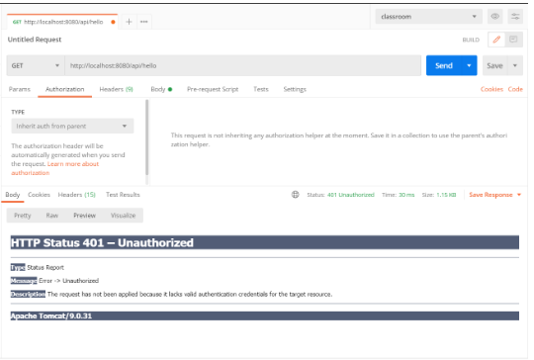
Sau đó chúng ta sẽ truy cập đường dẫn localhost:8080/api/login và chọn phương thức POST để test đăng nhập
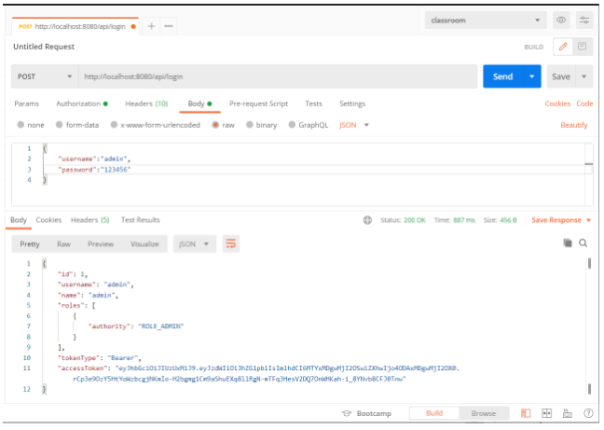
Trong đó accessToken là đoạn token được sử dụng để truy cập vào các API, tokenType là loại của Token.
Để sử dụng đoạn token trên chúng ta vào thẻ Authorization, ở thẻ Type chọn Bearer Token
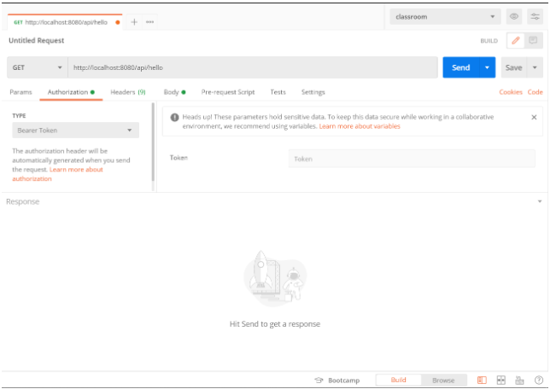
Ở phần Token chúng ta dán giá trị của accessToken vừa lấy được sau khi đăng nhập vào ô này và ấn nút Send để thử lại và thu được kết quả như sau:
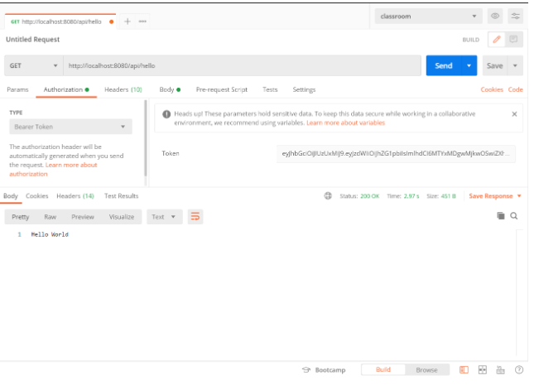
Checkout sang nhánh develop để xem mã nguồn tham khảo: https://github.com/codegym-vn/spring-jwt

Hướng dẫn nộp bài:
Up code lên github.
Paste link github vào phần nộp bài.

